----------------------------------------------------------------------------------------------------------------
NAME: VISHAL.V
REG.NO: 192419033
COURSE CODE: ECA0404
COURSE NAME: ANALOG CIRCUITS
PRACTICAL LAB RESULTS
----------------------------------------------------------------------------------------------------------------
EXP-7 (LT spice experiment)
CIRCIUT DIAGRAM:
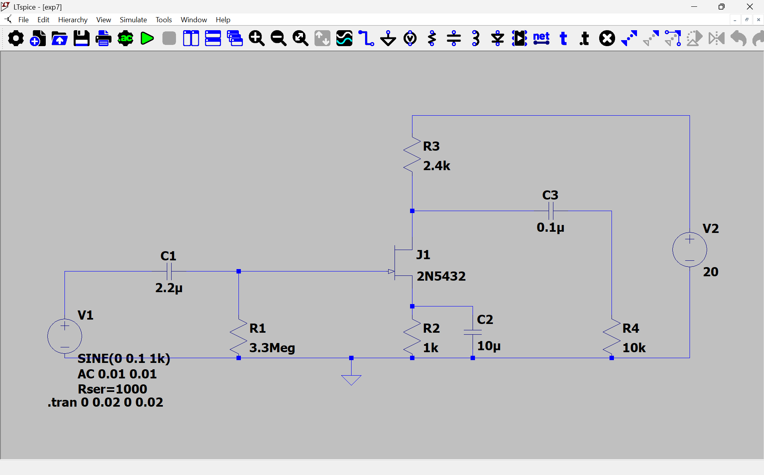

EXPERIMENTAL PROCEDURE
1. Apply constant input voltage.
2. Start at 20 Hz.
3. Record output voltage.
4. Increase frequency gradually.
5. Continue measurements up to 1 MHz.
6. Calculate gain.
7. Convert gain into dB.
8. Plot Bode magnitude response.
9. Determine bandwidth.

EXPERIMENTAL PROCEDURE
1. Set input voltage constant.
2. Start at 20 Hz.
3. Measure output voltage.
4. Increase frequency gradually.
5. Determine gain at each frequency.
6. Find frequencies corresponding to -3 dB points.
7. Calculate bandwidth.

Design Procedure
1. Select the FET device (e.g., 2N5457 or 2N7000).
2. Choose the supply voltage (typically 12 V).
3. Select RD and RS to obtain a suitable operating point.
4. Choose RG to provide proper gate bias.
5. Connect coupling and bypass capacitors.
6. Draw the circuit in LTspice.
7. Verify all component values.

OUTPUT(GRAPH): -
